**TASK 3 - Implement Virtual OS using Oracle VM VirtualBox.**

**Aim** : To create and run a Virtual OS (Windows XP) using Oracle VM VirtualBox.

**Description:**

**Virtualization** - Virtualization means to create a virtual version of a device or resource, such as a server, storage device, network or even an operating system where the framework divides the resource into one or more execution environments. Even something as simple as partitioning a hard drive is considered virtualization because you take one drive and partition it to create two separate hard drives. Devices, applications and human users are able to interact with the virtual resource as if it were a real single logical resource.

The minimum RAM requirement to do the experiment is 8GB, minimum hard disk space required is 250MB with i7 processor or processor with higher capacity.To reduce the costs for installation of OSes, we use Virtualization using open source Oracle VM VirtualBox.

**Procedure :**

**Step 1:**

Initially we need to download an iso file of Windows XP. Since it is already present in the CC Lab folder we undergo the following process. Go to Dashhome and type \\10.0.6.46

Click on Desktop -> Click on Cloud -> Copy the image file of Windows XP i.e pcriver.com_Windows_XP_Pro_SP3_32_bit.iso to the desktop.

**Step 2** : Open Oracle VM Virtual Box.

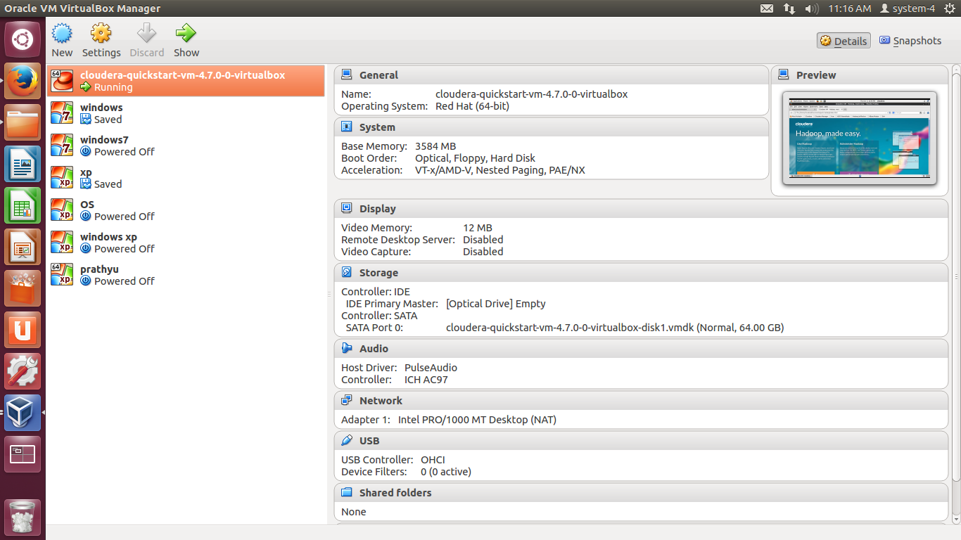

**Step 3** : Click on New and Enter any name for the OS, Select the type,Version of OS and Click Next.

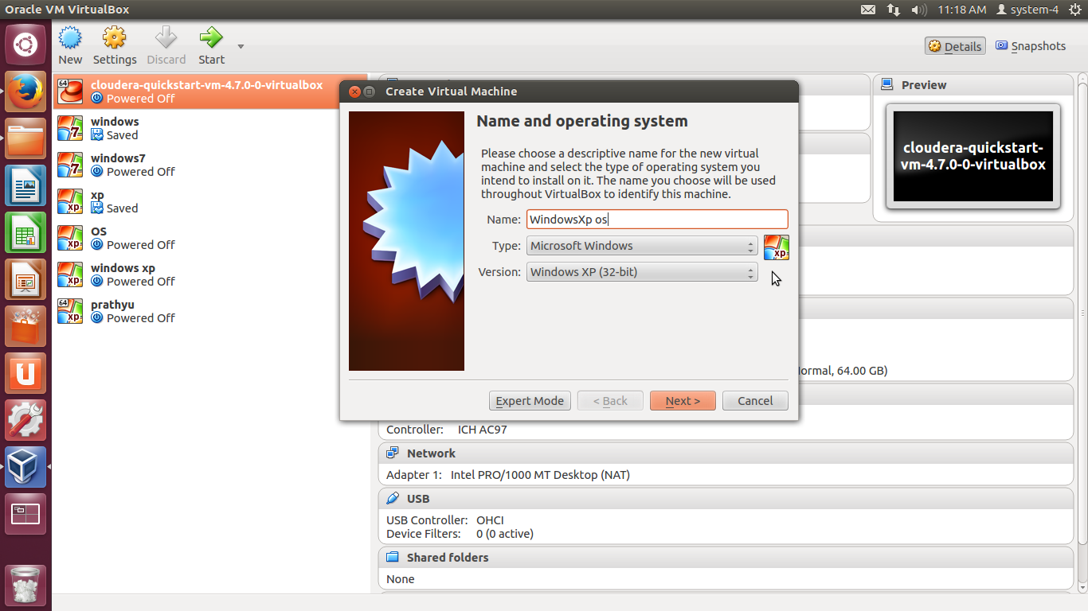

**Step 4** : Select memory size of the RAM allocated to OS. The minimum requirement is 192MB, but the system becomes slow. So select any higher memory, for instance 448MB.

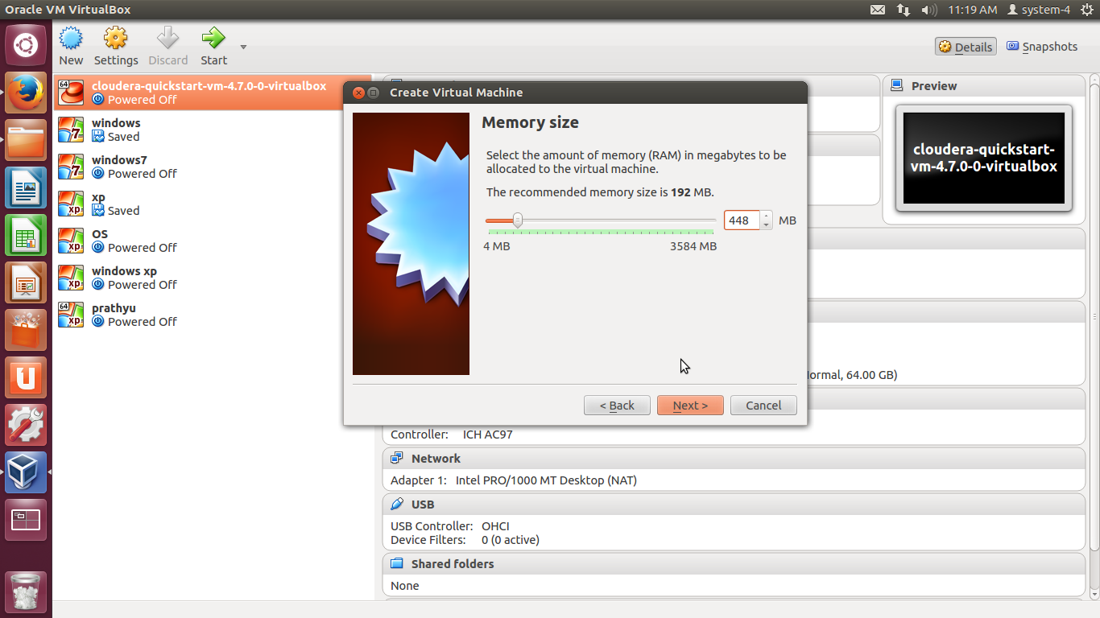

**Step 5** : Select Create a Virtual hard disk now

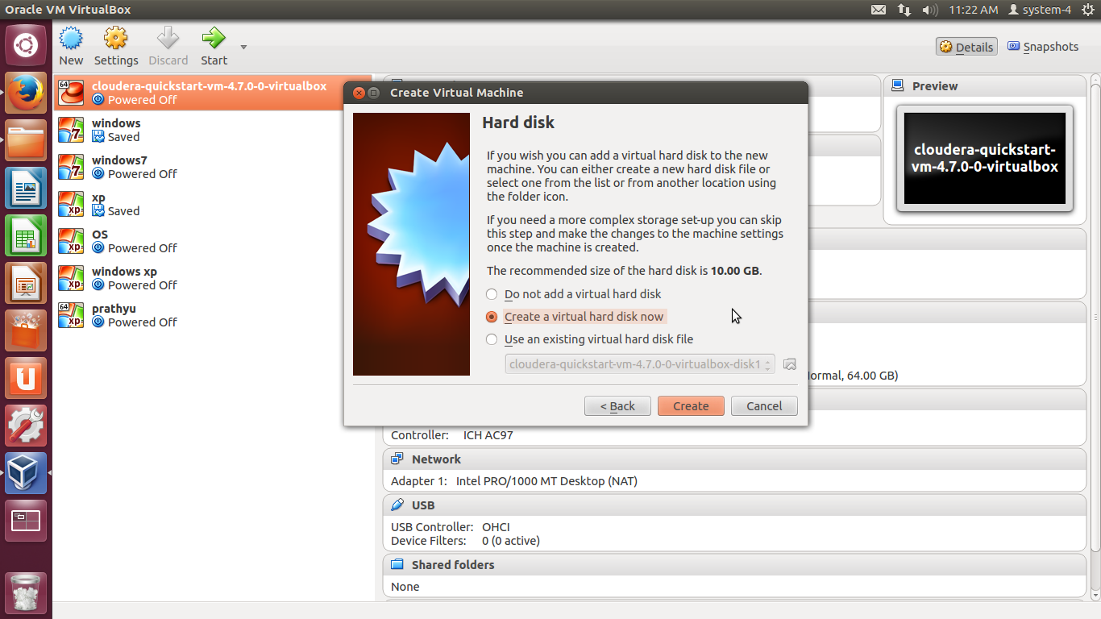

**Step 6** : Select the VDI(VirtualBox Disk Image) and click next.

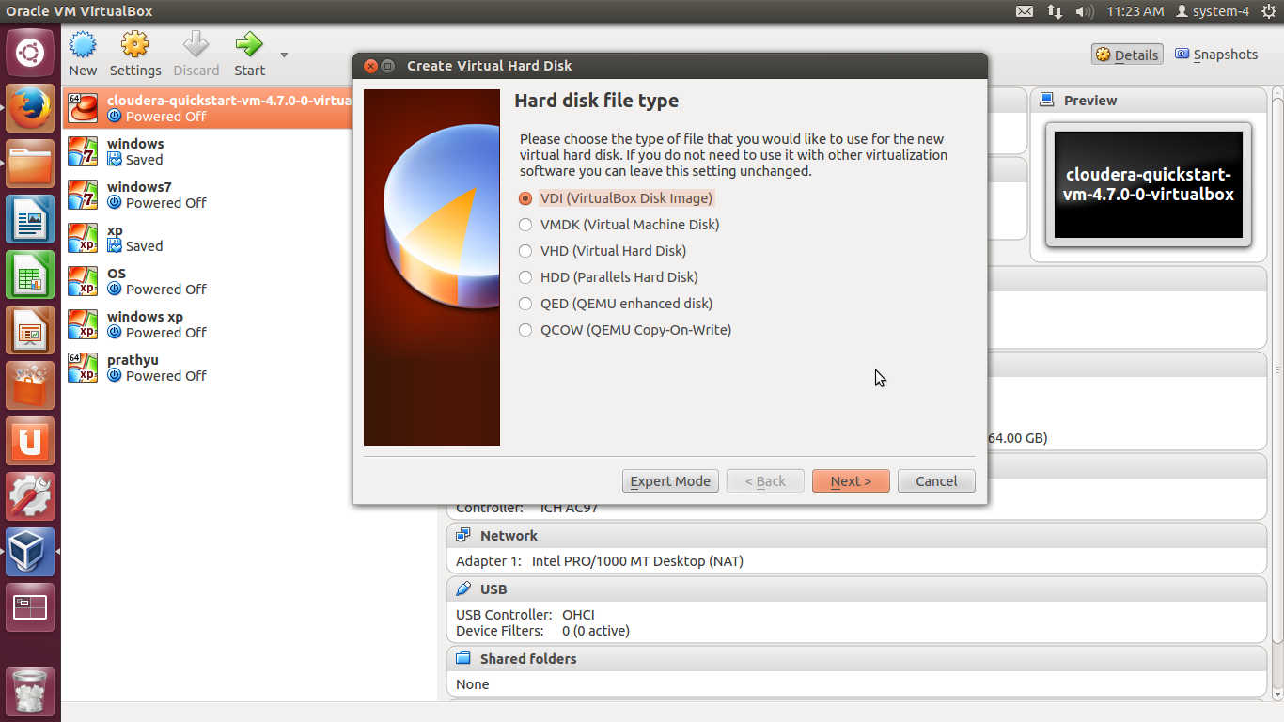

**Step 7** : Select Dynamically allocated and move next.

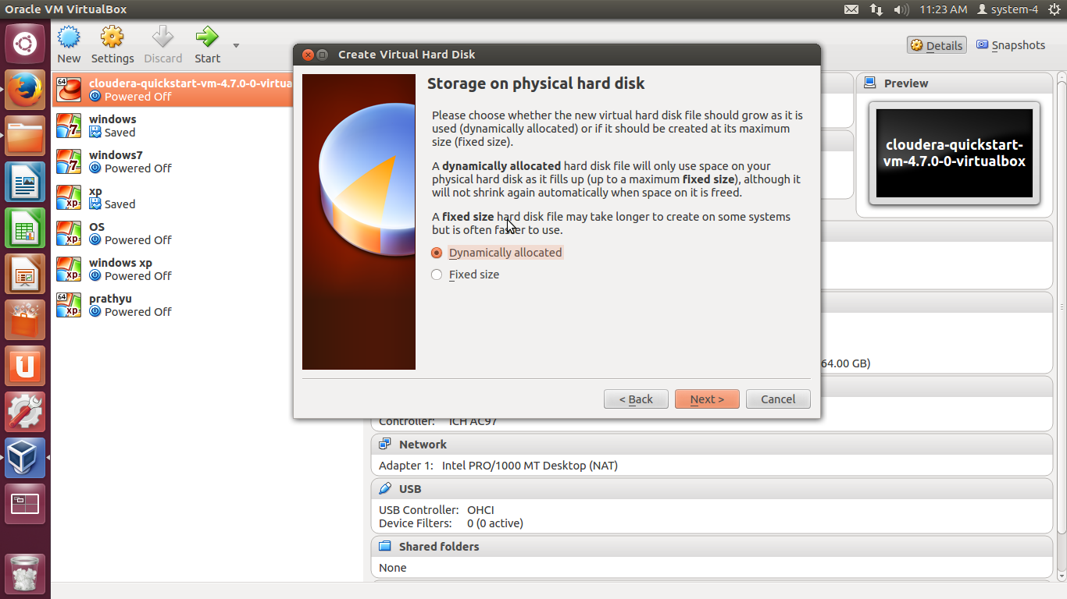

**Step 8** : Select a size for the hard disk (eg 20GB) and click on Create.

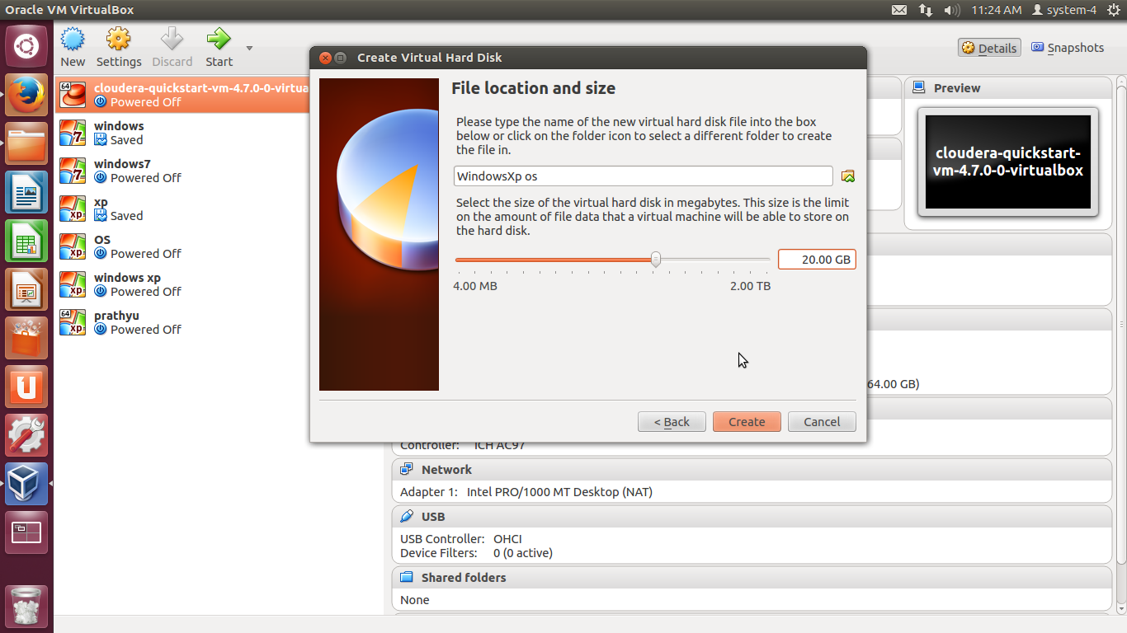

Step 9 : Now right click on the Newly Created OS and click on Settings.

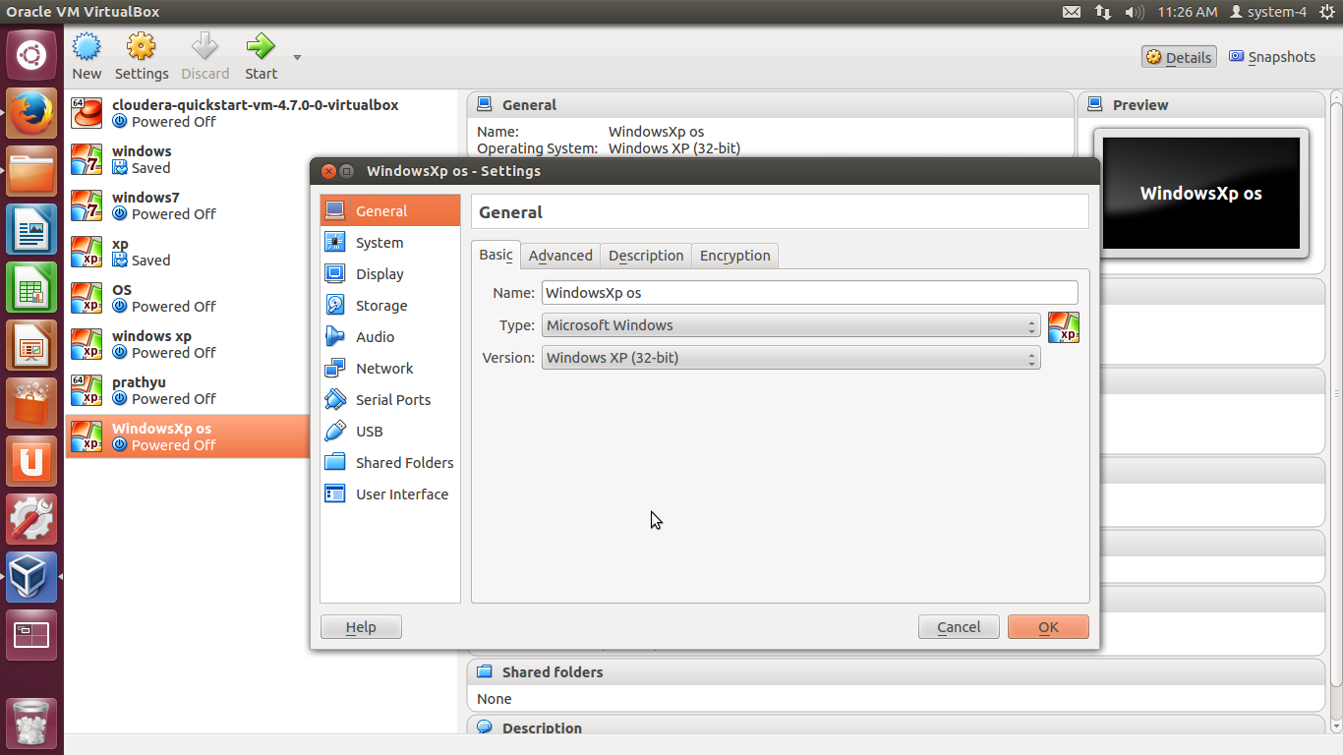

**Step 10** : **Click on Storage ->** **Click on Empty tab ->** **Click on Browse(CD button)** and select the image file pcriver.com_Windows_XP_Pro_SP3_32_bit.iso

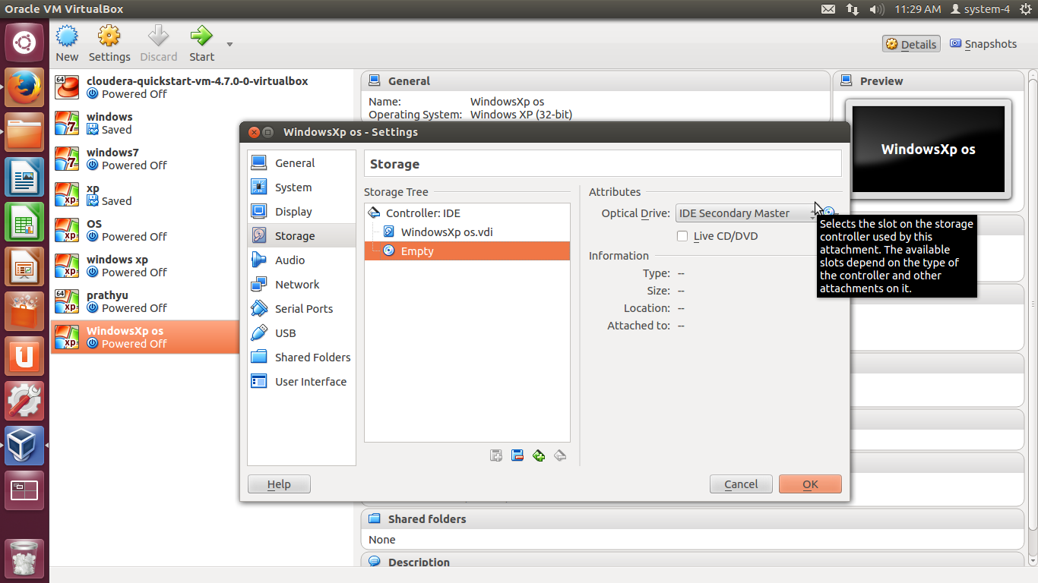

**Step 11** : Now click on OK.

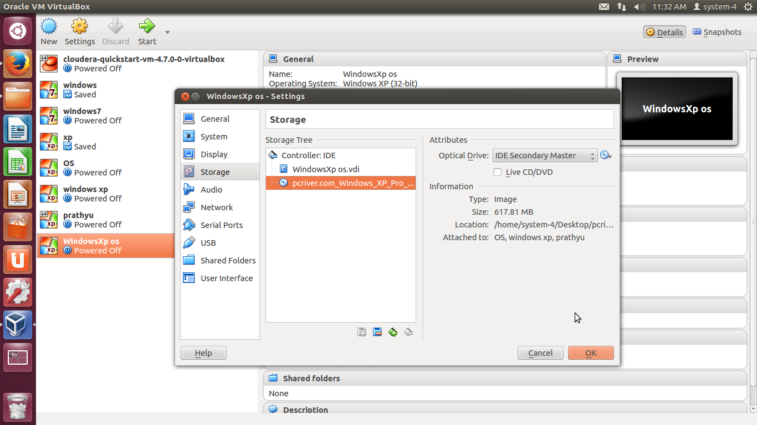

**Step 12** : Double click on the newly created OS or simply select the OS and Click start arrow at the top to Start the OS.

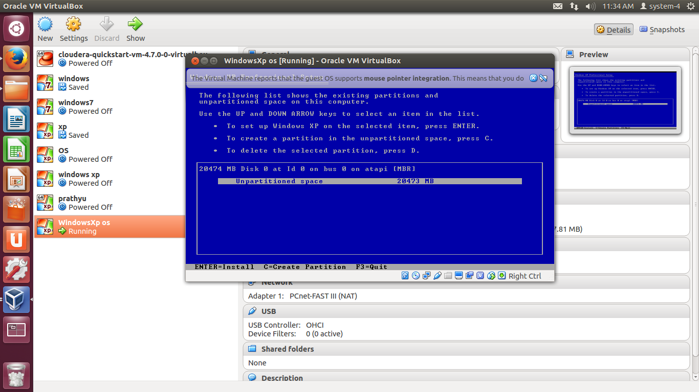

**Step 13 :** Select the default option and continue the process**.**

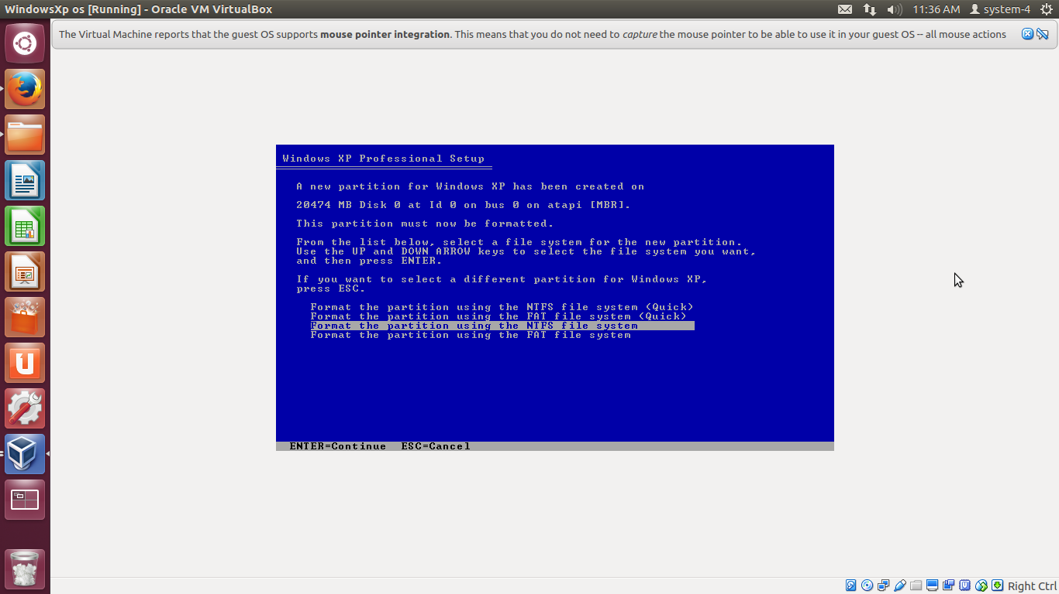

The following describes the setting up of the above selected default partition option.

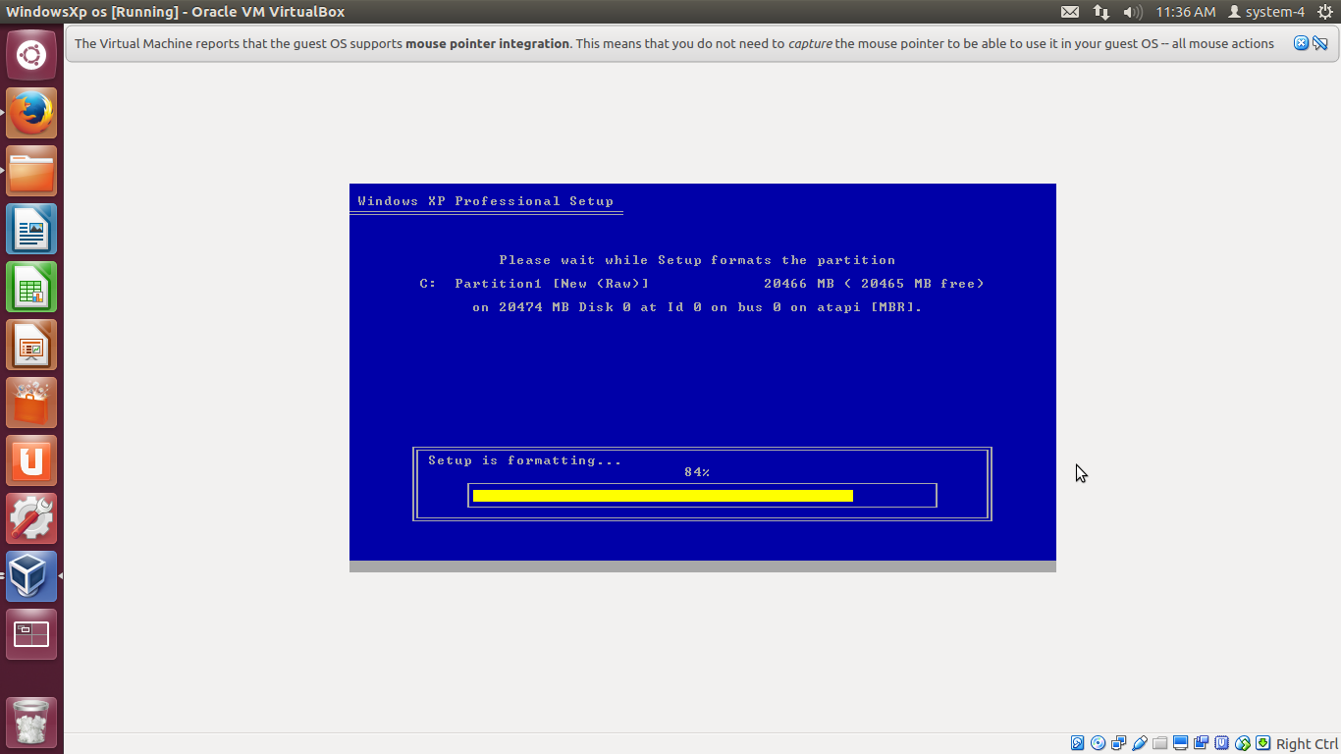

Here the files are been loading i.e copying in to the System to make it ready .

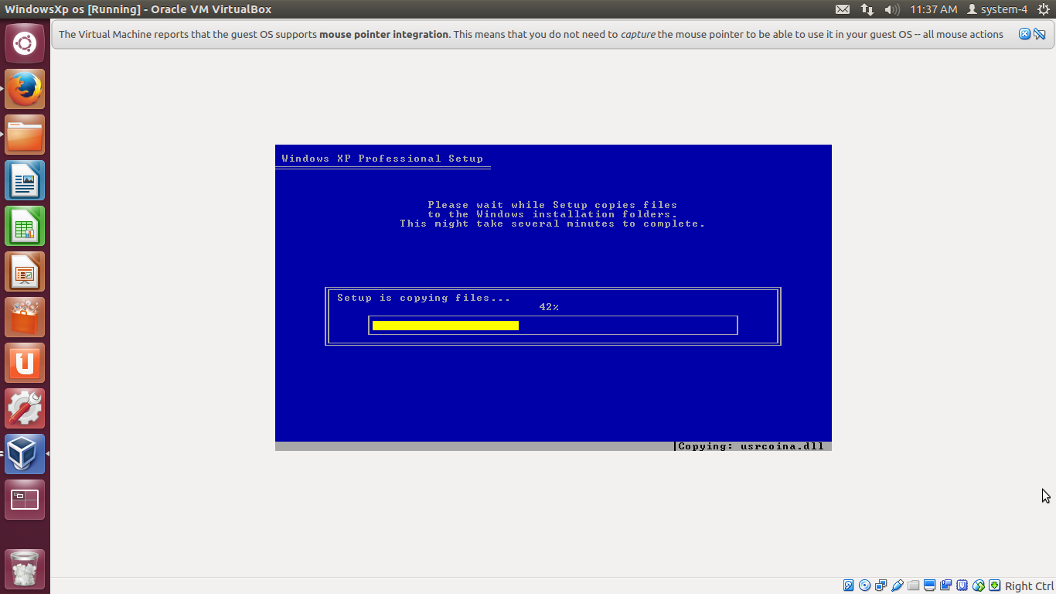

The following images signifies that the setup process has completed successfully and the windows is starting.

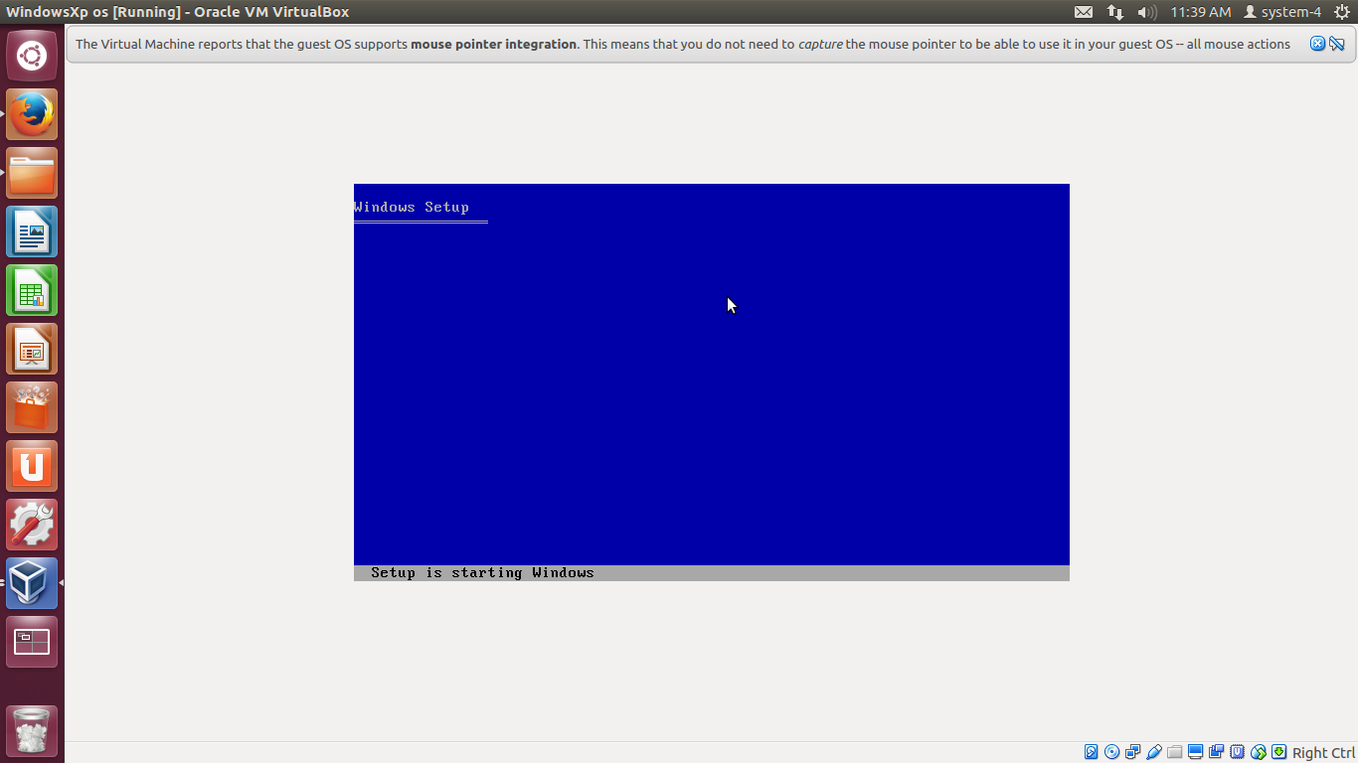

**Windows Xp OS will be opened.**

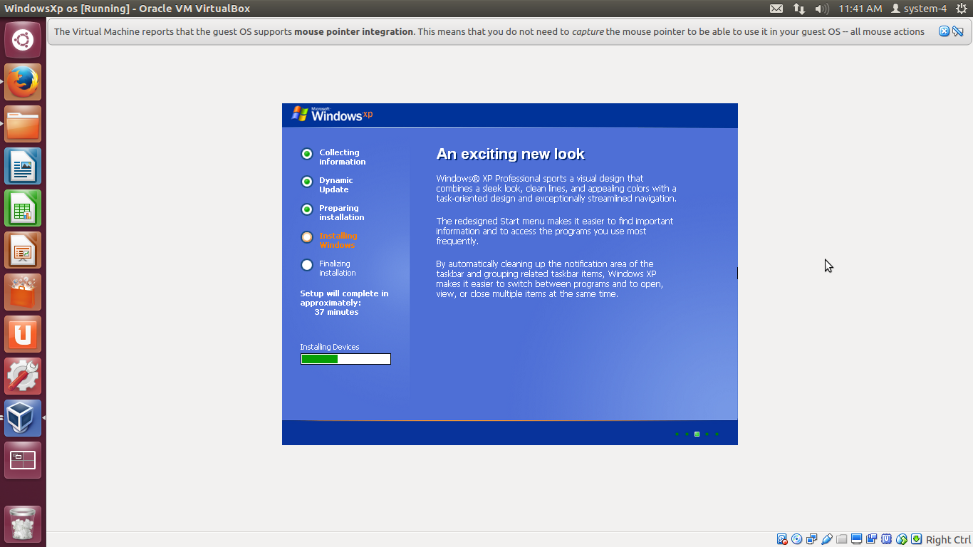

**Step 14** : Click on Customize to change language settings.

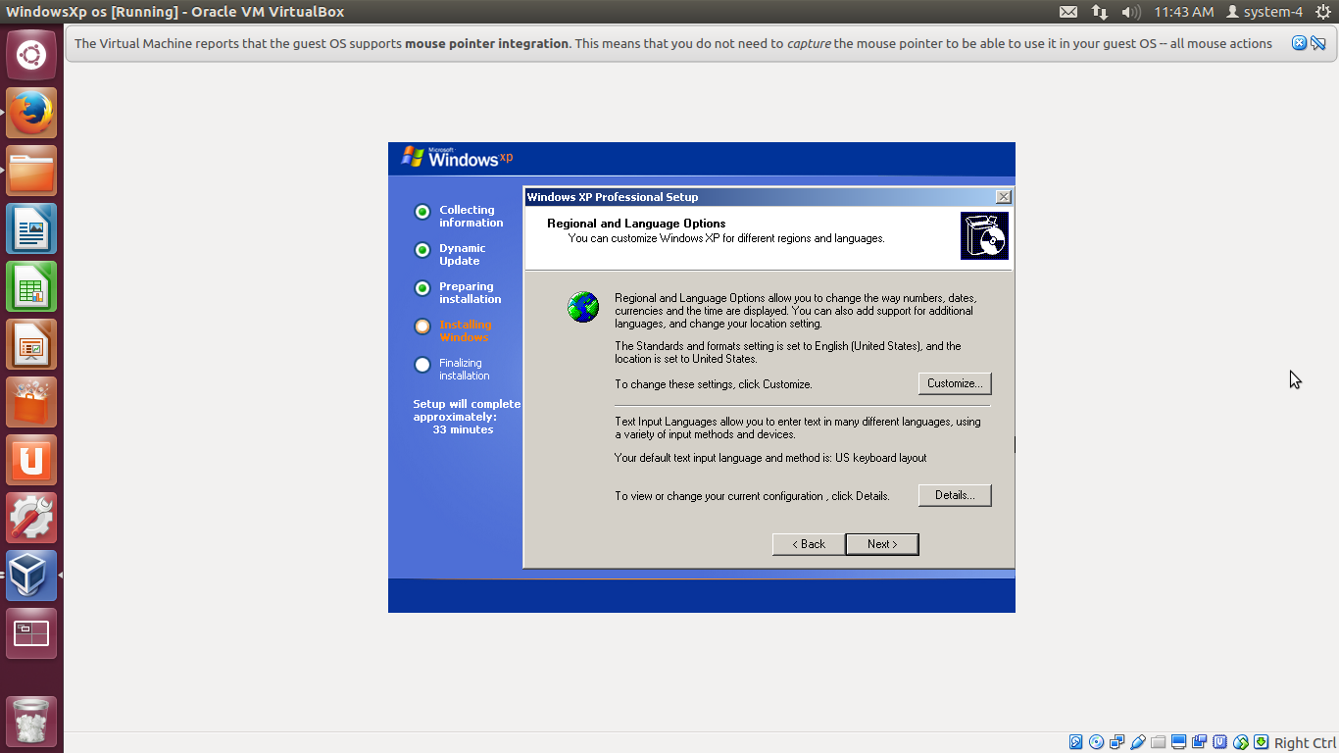

**Step 15**: Enter Name and Organisation of your choice.

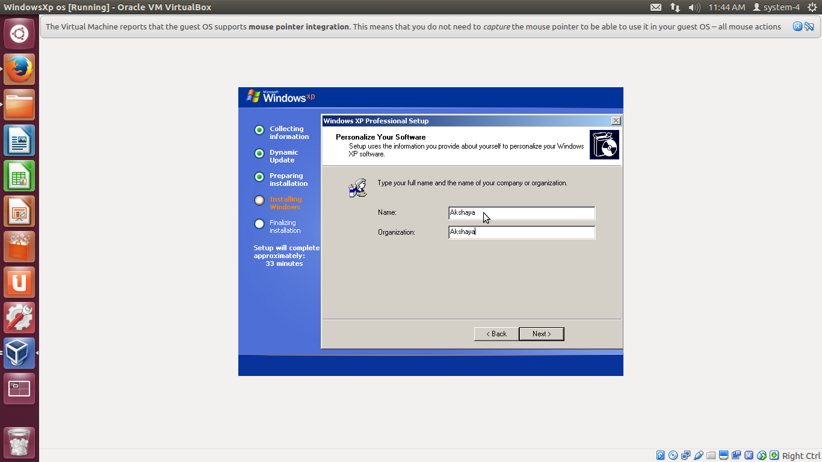

**Step 16** : Enter the computer name .

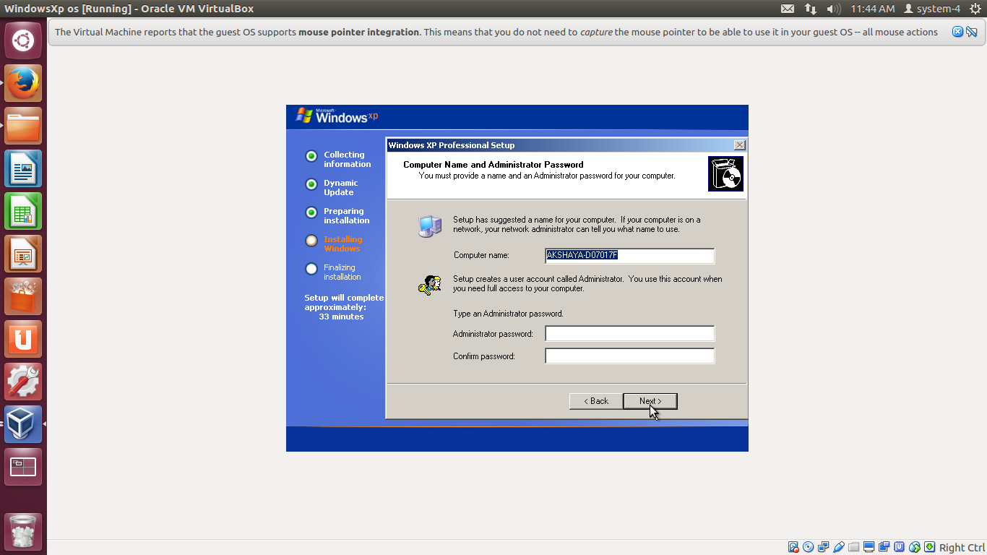

**Step 17 :** Set the date and time based on your time zone.

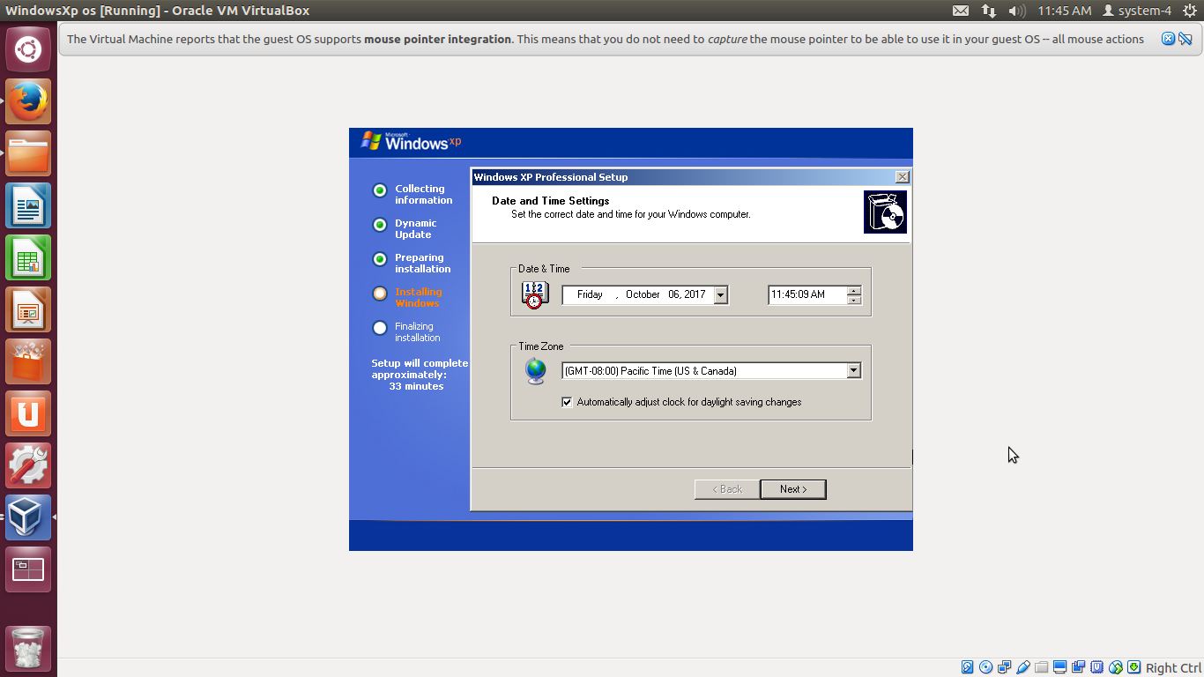

**Step 18** : Select No and continue with the further process.

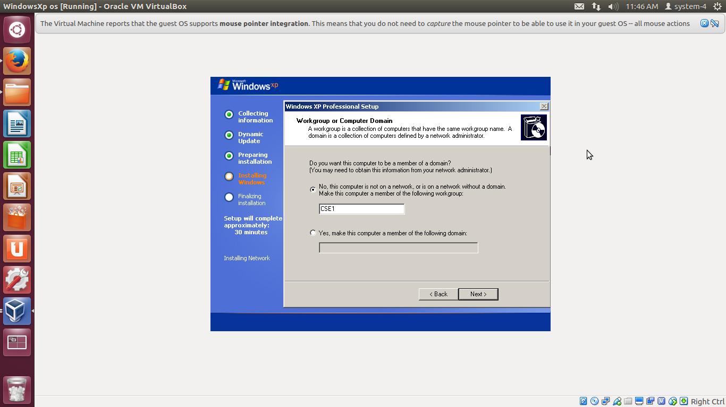

Copying of files takes place.

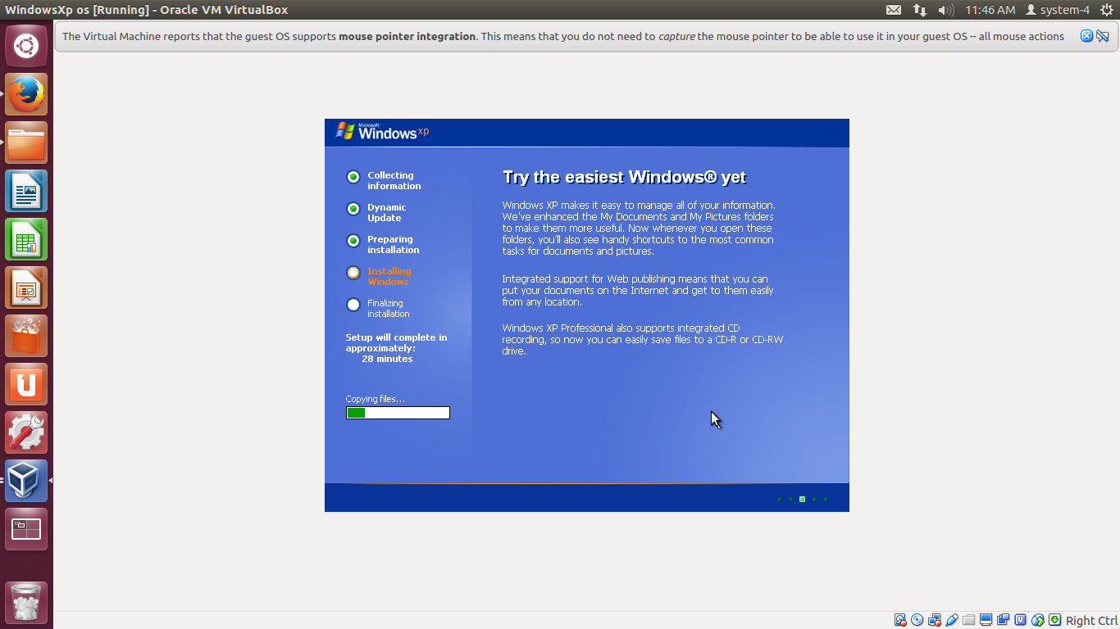

**Step 19** : Choose the appropriate option based on your purpose and select.

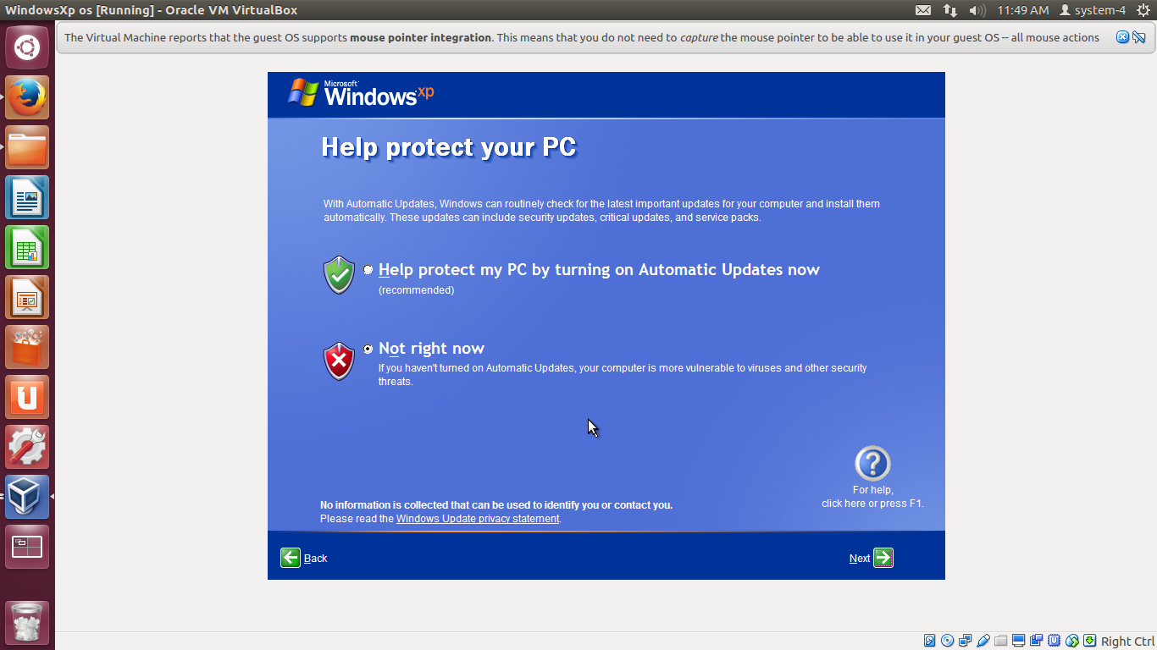

**Step 20** : Set the internet connectivity options based on your requirement and proceed.

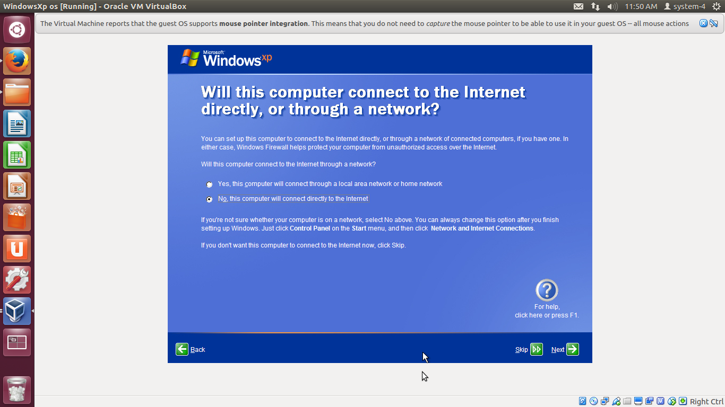

**Step 21** : Now select whether to register or not and continue the process.

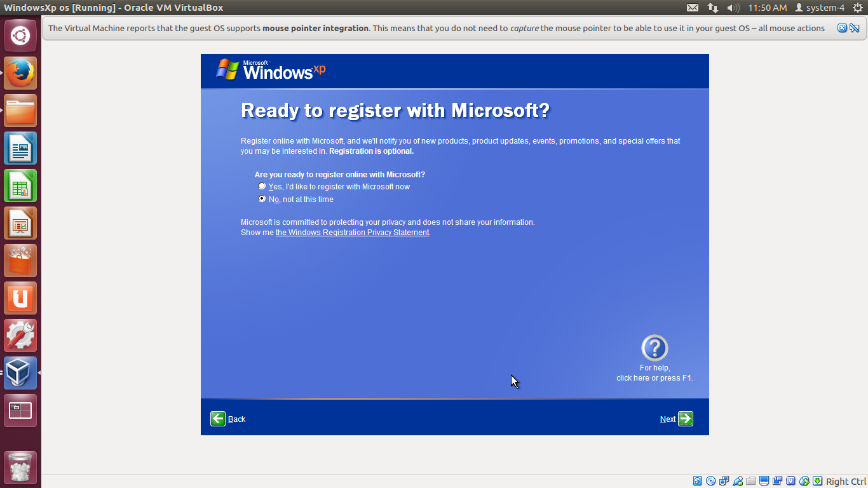

Now Enter the username of the computer

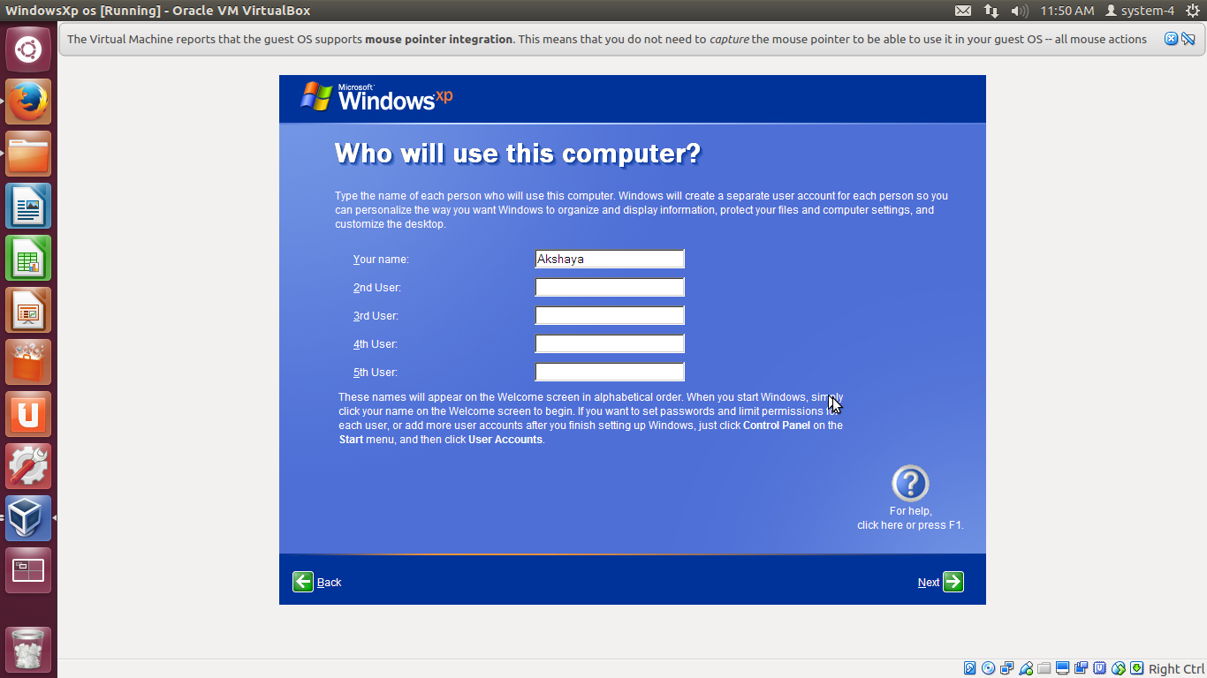Now we can see the Windows XP OS on a computer that is running Ubuntu OS.

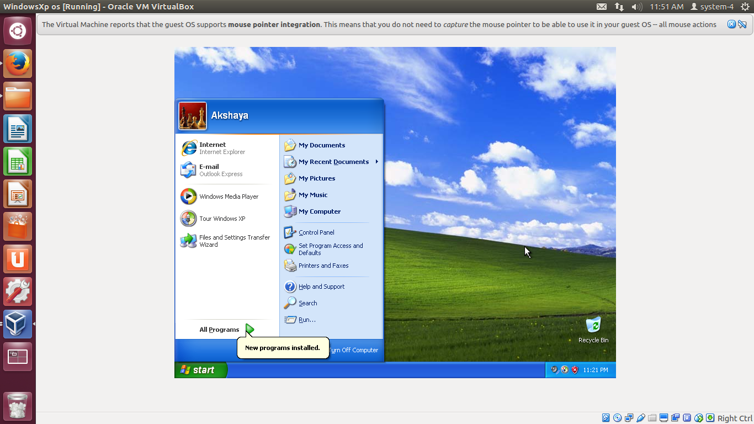

To turn off the virtual OS just click on to cross button on the top-right and select to power off the machine.

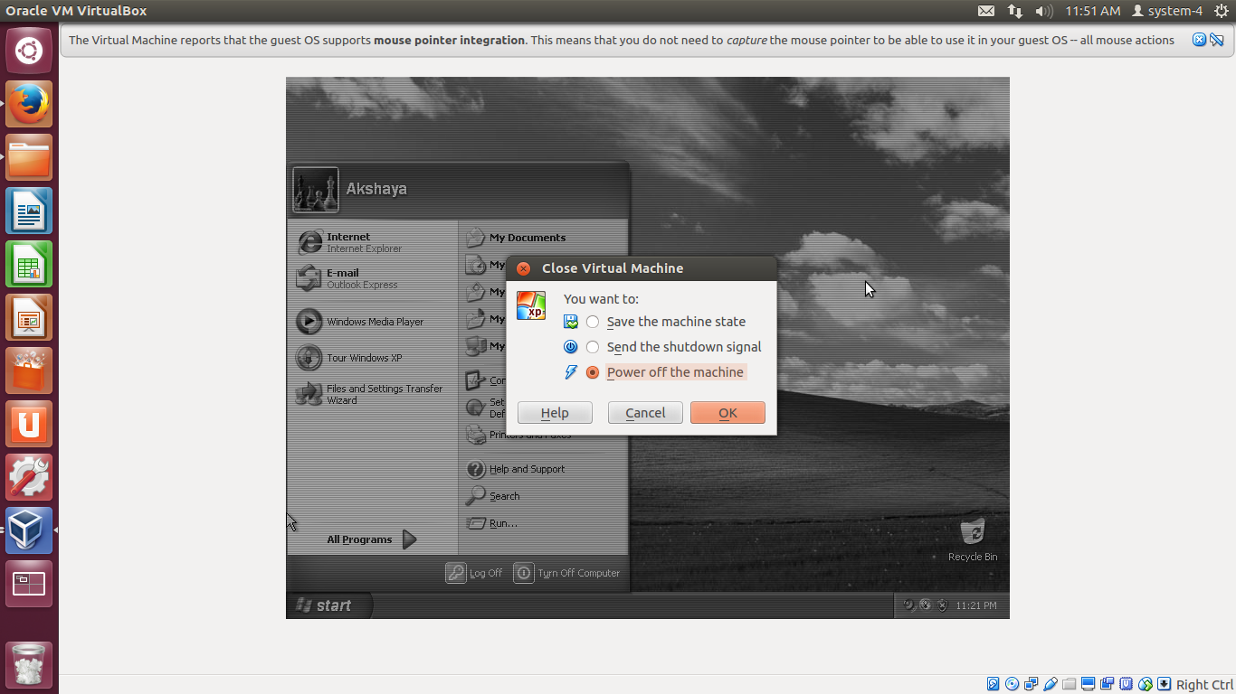

**RESULT :** Hence implementation of virtual OS using Oracle’s virtual Box completed successfully.